BENEFITS OF MEMBERSHIP
- BEING PART OF A CLUB WITH PEOPLE WHO CARE
- SHARING WITH MOPAR ENTHUSIASTS
- MONTHLY NEWSLETTER
- CLUB MEMBERSHIP SHIRT
- CLASSIFIED ADVERTISING ON
WEB PAGE AND NEWSLETTERS
- MONTHLY MEETINGS
- ANNUAL EVENTS FOR YOUR FAMILY
- MEMBER DISCOUNTS
TO SUBMIT ARTICLES FOR OUR NEWSLETTER, e-mail indymoparclub@indymoparclub.com
NEED MORE INFORMATION?
indymoparclub@indymoparclub.com
STEVE WISDOM
PRESIDENT
(317) 888-7019
BOB ROSENBERGER
VICE PRESIDENT
(317) 947-0432
MIKE LEYES
TREASURER
(765) 524-0326
KAREN ROSENBERGER
SECRETARY
(317) 947-0432
DAVE WATT
COMMUNICATIONS DIRECTOR
(317) 336-6354

INDY MOPAR CLUB
GOALS
To create good fellowship and sportsmanship among members of the club and families
To provide our members with technical, mechanical and restoration help
To offer our members a source to buy, trade or sell Mopar parts
To offer the surrounding communities a collector club supporting the public, press and law enforcements agencies.
To promote safety in driving, automotive maintenance and overall vehicle operation.
To support the Juvenile Diabetes Research Foundation.
To hold special events for all types of collector cars.
To seek young men/women and teach them to appreciate the collector cars of yesteryear.
Maintain a website at: www.indymoparclub.com

INDY MOPAR CLUB
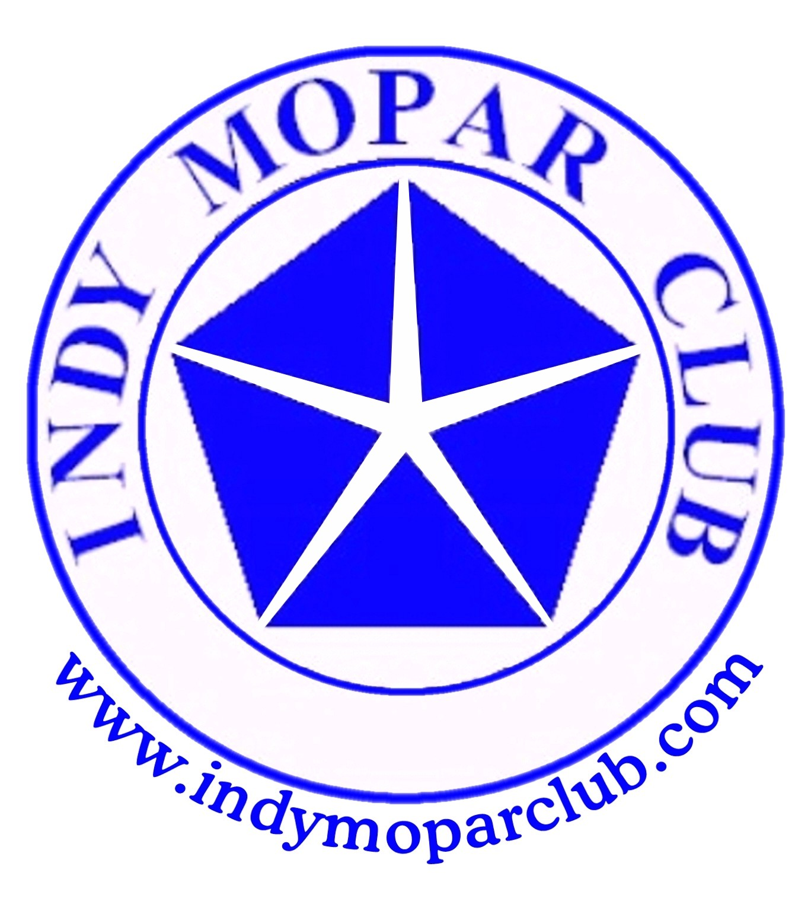
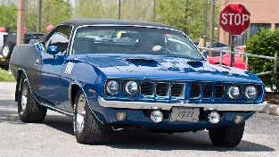




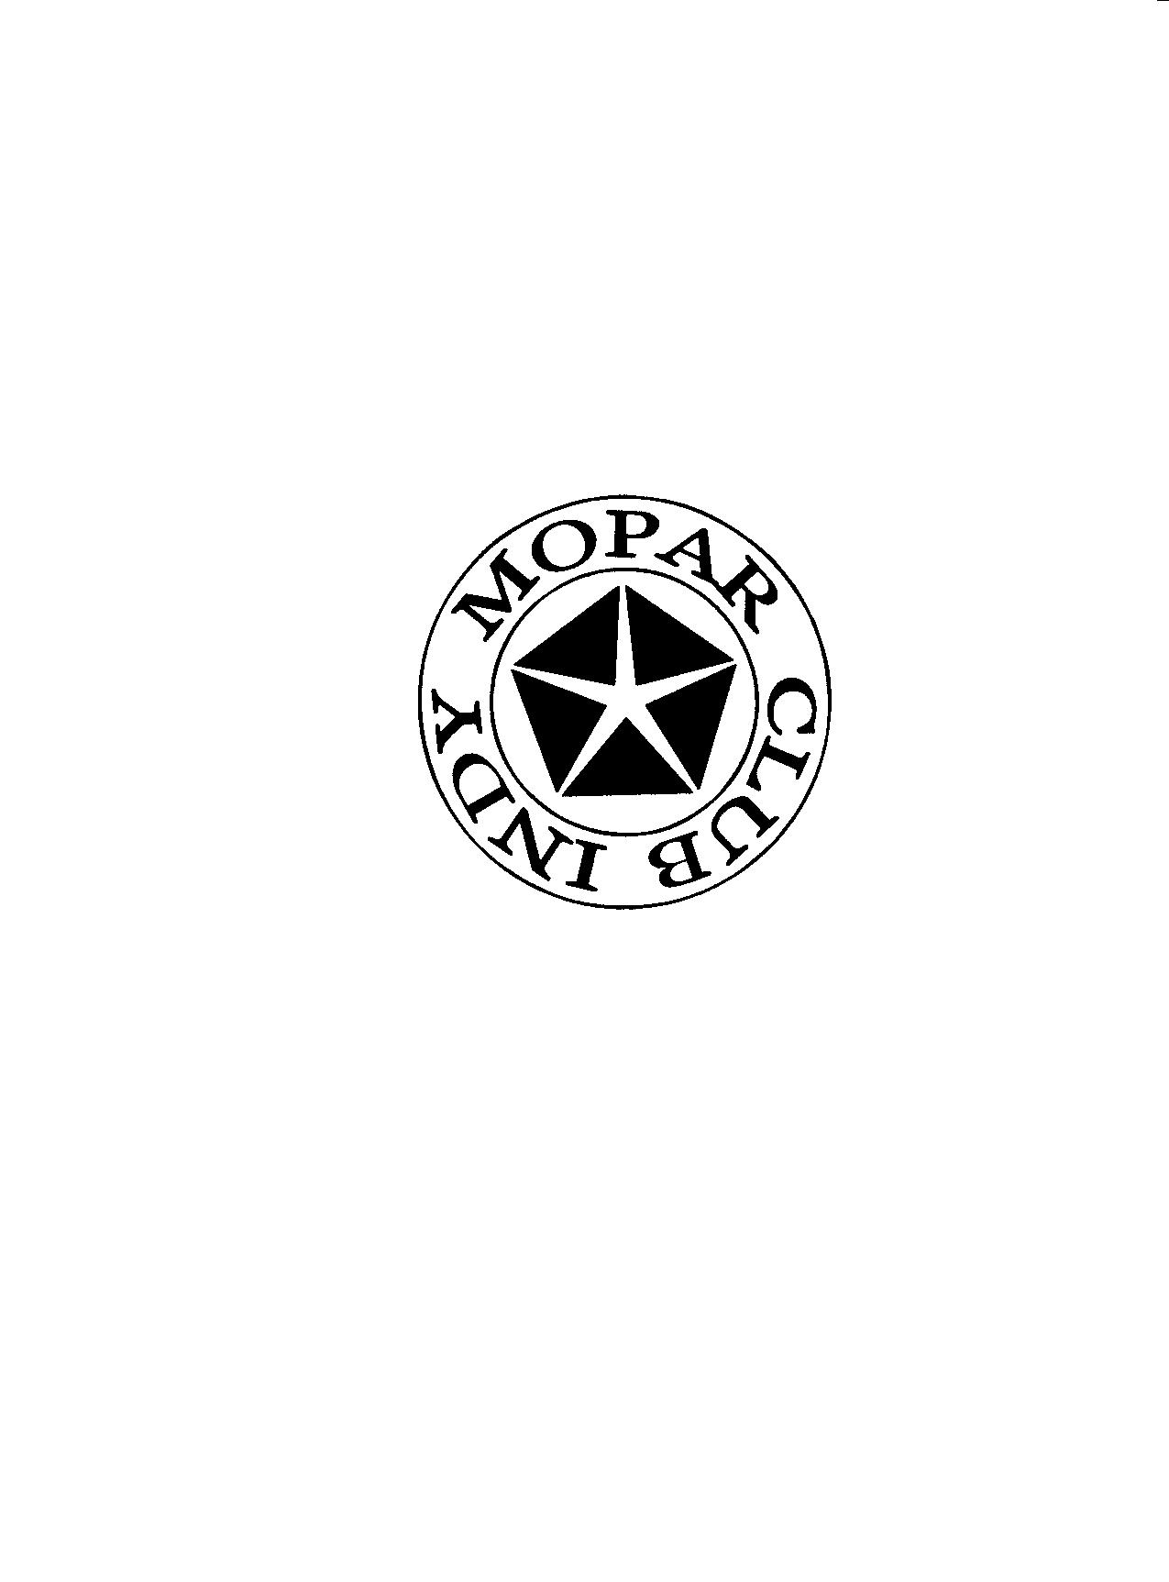
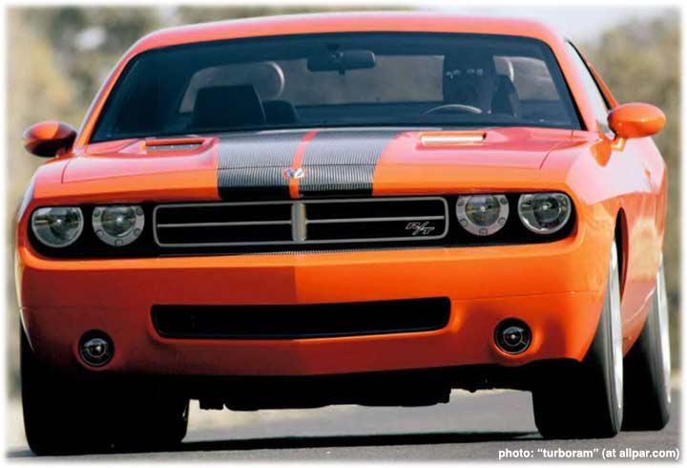
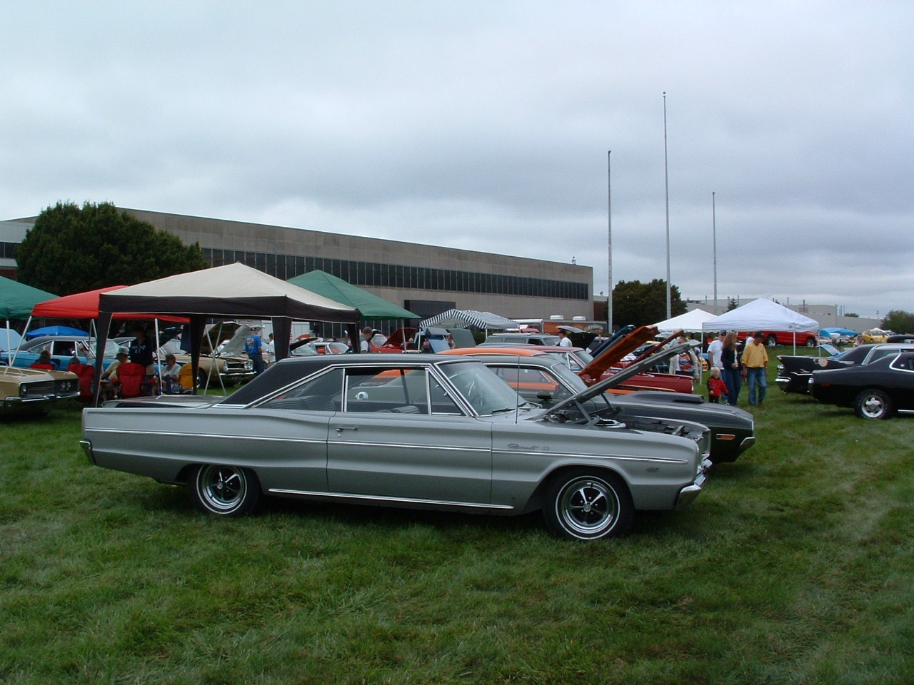
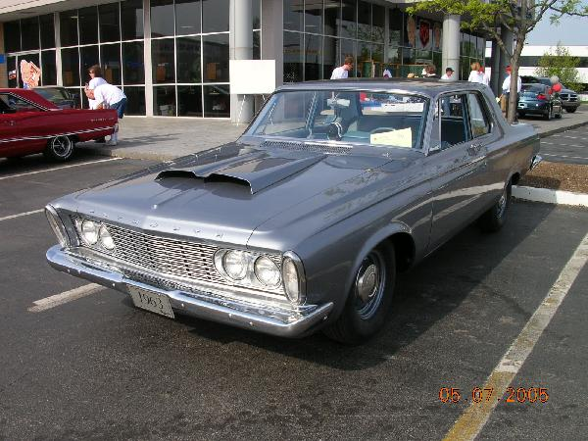
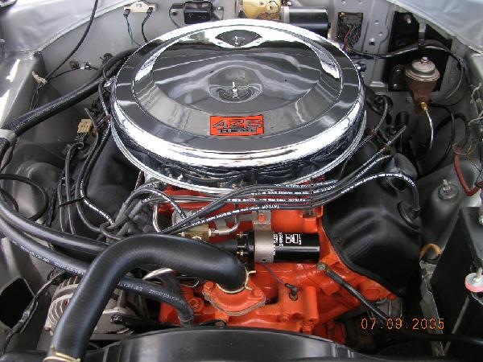
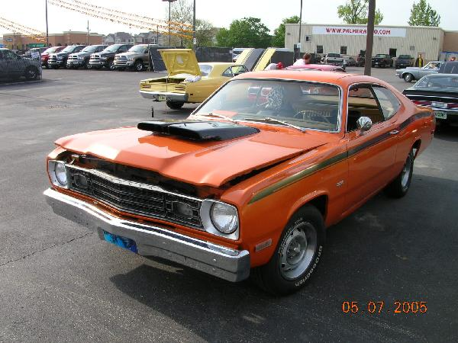

JOHN BAUER—PRESIDENT

bauerconstruction@tds.net

(317)769.3312

DAN KELLY—VICE PRESIDENT

K4138@indygov.org

(317)442-6446

To create good fellowship and sportsmanship among members of the club and families
To provide our members with technical, mechanical and restoration help
To offer our members a source to buy, trade or sell Mopar parts
To offer the surrounding communities a collector club supporting the public, press and law enforcements agencies
To promote safety in driving, automotive maintenance and overall vehicle operation
To support the Juvenile Diabetes Research Foundation
To hold special events for all types of collector cars
To seek young men/women and teach them to appreciate the collector cars of yesteryears
Maintain a website at www.indymopar.com

ABOUT THE CLUB
INDY MOPAR CLUB
BENEFITS OF MEMBERSHIP
BEING PART OF A CLUB WITH PEOPLE WHO CARE
SHARING WITH MOPAR ENTHUSIASTS
MONTHLY NEWSLETTER
CLUB T-SHIRT
CLASSIFIED ADVERTISING ON WEB PAGE AND NEWSLETTERS
MONTHLY MEETINGS
ANNUAL EVENTS FOR YOUR FAMILY
MEMBER DISCOUNTS
TO SUBMIT ARTICLES FOR OUR NEWSLETTER
CONTACT: MEMBER DAVE WATT
WATT340@hrtc.net
336.6354
NEED MORE INFORMATION
JOHN BAUER — PRESIDENT 317.430.1265
DAN KELLY—VICE PRESIDENT
317.442.6446
MIKE LEYES—TREASURER 765.524.0326
DAVE WATT — COMMUNICATIONS/NEWS
317.336.6354
CHRIS RIGBY— SECRETARY 317.865.3659

JOHN BAUER—TREASURER 317.769.3312
FOR UPDATED INFORMATION CHECK OUR WEB PAGE AT WWW.INDYMOPARCLUB.COM

