PERSONAL INFORMATION
DATE OF BIRTH: ___________________________
DATE OF ANNIVERSARY: __________________
CHILDREN NAME(S) AND AGES:
____________________________________________________________________________________________________________________________________________________________________________________________________________________________________________________________________________________
JOB FIELD: ______________________________________

CHECK EVENTS WILLING TO VOLUNTEER:
- EVENTS/CAR SHOWS
- DOOR PRIZES FOR CAR SHOWS/EVENTS
- NEWSLETTERS/MAILINGS
- MEMBERSHIP EFFORTS
- WEB PAGE UPDATES
- FLYER PREPARATIONS

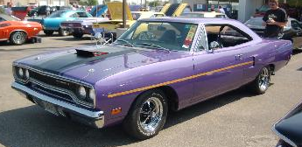
2009 CLUB EVENTS
MARCH 7-8, 2009
CHRYSLER PERFORMANCE TRADE SHOW AND SWAP MEET presented by INDY CYLINDER HEAD
Indiana State Fairgrounds
MAY 2, 2009
OPEN CAR SHOW
Palmer Chrysler Dodge Jeep
5051 West Pike Plaza Road, Indianapolis
JUNE 20, 2009
OPEN CAR SHOW
Fletcher Chrysler Dodge Jeep
3099 S. Morton Street (US 31) Franklin, IN
AUGUST 7-9, 2009
CLUB EVENT AT MOPAR NATIONALS
Columbus Ohio
SEPTEMBER 19, 2009
OPEN CAR SHOW
Danville Chrysler Dodge Jeep
173 S. Co. Road 525 East, Danville, IN
NOVEMBER 2009
OFFICER ELECTIONS FOR 2010

DECEMBER 2009
ANNUAL CHRISTMAS PARTY
No monthly meeting due to the holidays

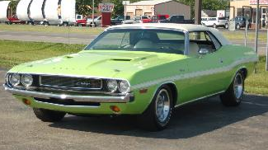

APPLICATION
$30.00 per year includes a membership shirt.
Send Check or Money Order to:
INDY MOPAR CLUB
ATTN: MIKE LEYES
3130 E Hardacre Court
New Castle, IN 47362
PLEASE PRINT YOUR INFORMATION
NAME: ____________________________________________________
SPOUSE NAME: ____________________________________________
ADDRESS: ________________________________________________
CITY: _____________________________________________________
STATE: _______________________________ ZIP: ______________
TELEPHONE: ( ) ______________________________________
CELL PHONE: ( ) ______________________________________
E-MAIL ADDRESS: _________________________________________
VEHICLE INFORMATION: CAR #1
YEAR: _____________________________________________________
MAKE: ____________________________________________________
MODEL: ___________________________________________________
VEHICLE INFORMATION: CAR #2
YEAR: _____________________________________________________
MAKE: ____________________________________________________
MODEL: ___________________________________________________
CIRCLE SIZE OF SHIRT
M L XL 2X 3X
TO BECOME A MEMBER, ONE MUST OWN A MOPAR CAR OR TRUCK AND BE AT LEAST 16 YEARS OF AGE. THE VEHICLE MAY BE UNDER CONSTRUCTION TO QUALIFY.
THE INFORMATION YOU HAVE PROVIDED IS KEPT CONFIDENTIAL TO THE CLUB REGISTRY, EXCEPT FOR RELEASE TO VENDORS WHO OFFER MEMBER DISCOUNTS TO VERIFY MEMBERSHIP


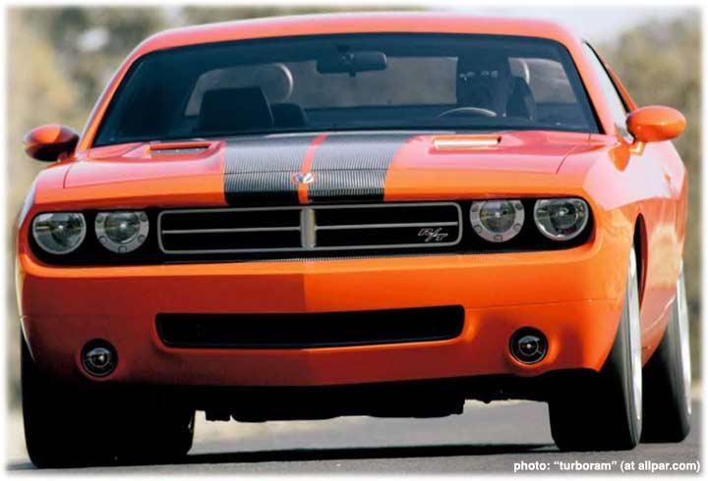
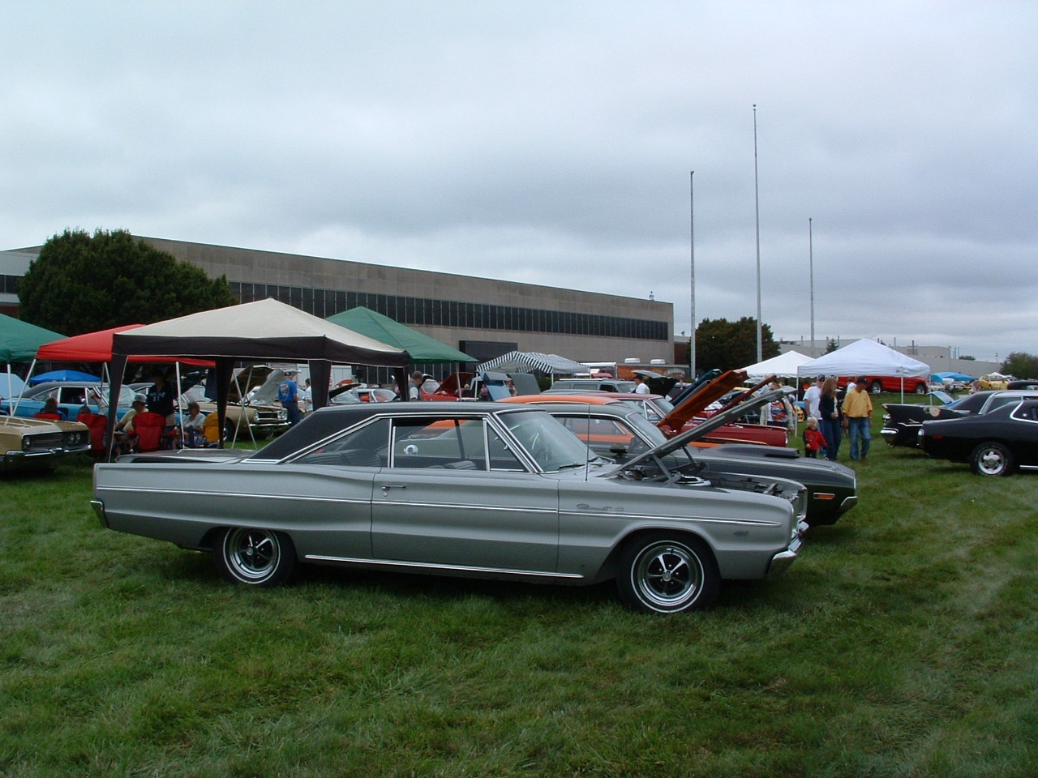
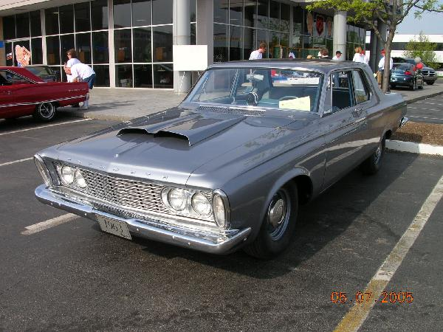
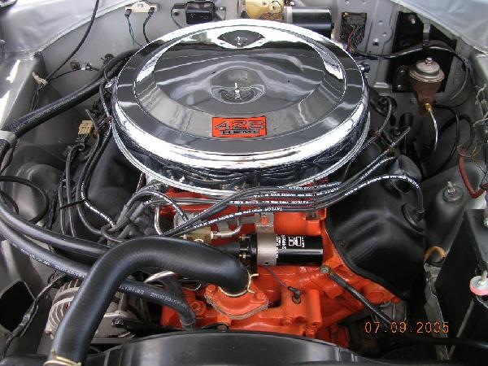

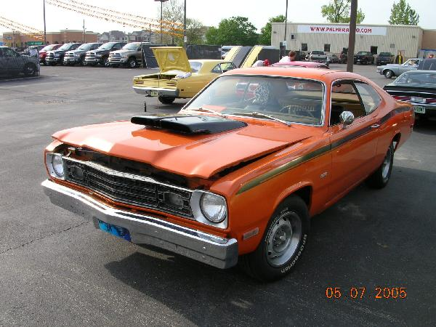

JOHN BAUER—PRESIDENT

bauerconstruction@tds.net

(317)769.3312

DAN KELLY—VICE PRESIDENT

K4138@indygov.org

(317)442-6446

To create good fellowship and sportsmanship among members of the club and families
To provide our members with technical, mechanical and restoration help
To offer our members a source to buy, trade or sell Mopar parts
To offer the surrounding communities a collector club supporting the public, press and law enforcements agencies
To promote safety in driving, automotive maintenance and overall vehicle operation
To support the Juvenile Diabetes Research Foundation
To hold special events for all types of collector cars
To seek young men/women and teach them to appreciate the collector cars of yesteryears
Maintain a website at www.indymopar.com

ABOUT THE CLUB
INDY MOPAR CLUB
BENEFITS OF MEMBERSHIP
BEING PART OF A CLUB WITH PEOPLE WHO CARE
SHARING WITH MOPAR ENTHUSIASTS
MONTHLY NEWSLETTER
CLUB T-SHIRT
CLASSIFIED ADVERTISING ON WEB PAGE AND NEWSLETTERS
MONTHLY MEETINGS
ANNUAL EVENTS FOR YOUR FAMILY
MEMBER DISCOUNTS
TO SUBMIT ARTICLES FOR OUR NEWSLETTER
CONTACT: MEMBER DAVE WATT
WATT340@hrtc.net
336.6354
NEED MORE INFORMATION
JOHN BAUER — PRESIDENT 317.430.1265
DAN KELLY—VICE PRESIDENT
317.442.6446
MIKE LEYES—TREASURER 765.524.0326
DAVE WATT — COMMUNICATIONS/NEWS
317.336.6354
CHRIS RIGBY— SECRETARY 317.865.3659

JOHN BAUER—TREASURER 317.769.3312
FOR UPDATED INFORMATION CHECK OUR WEB PAGE AT WWW.INDYMOPARCLUB.COM

